**Optimal Conditions for Different Crops**

1. CORN

Needs Higher Solar Isolation, hot days, and cool nights.

* 1. Temperature: 68 to 80 F (above 80 yield reduces)

1. SOYBEAN

It’s a warm season crop which requires very less nitrogen fertilizer.

* 1. Temperature: 68 to 86 F (above 100 F have adverse effects on crop)

1. WHEAT

For winter and spring wheat minimum daily temperature for measurable growth is about 5°C.

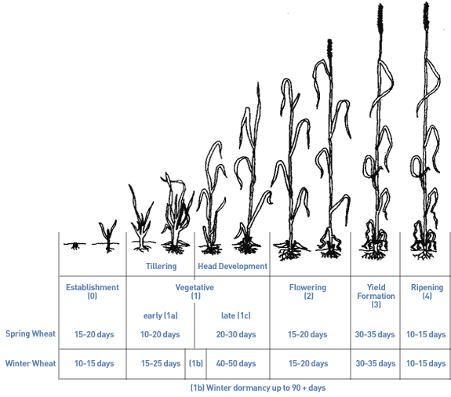

Mean daily temperature for optimum growth and tillering is between 15 and 20°C.

A dry, warm ripening period of 18°C or more is preferred. Mean daily temperatures of less than 10 to 12°C during the growing season make wheat a hazardous crop.

Winter wheat is more applicable than spring wheat in north America and Europe

Winter

Long day Cool season grasses

Winter wheat needs about 180 to 250 days to mature.

In early stages of development exhibits a strong resistance to frost, down to - 20°C.

Winter wheat should be seeded less than one inch (2.5 cm) below the soil surface into a firm, moist seedbed.

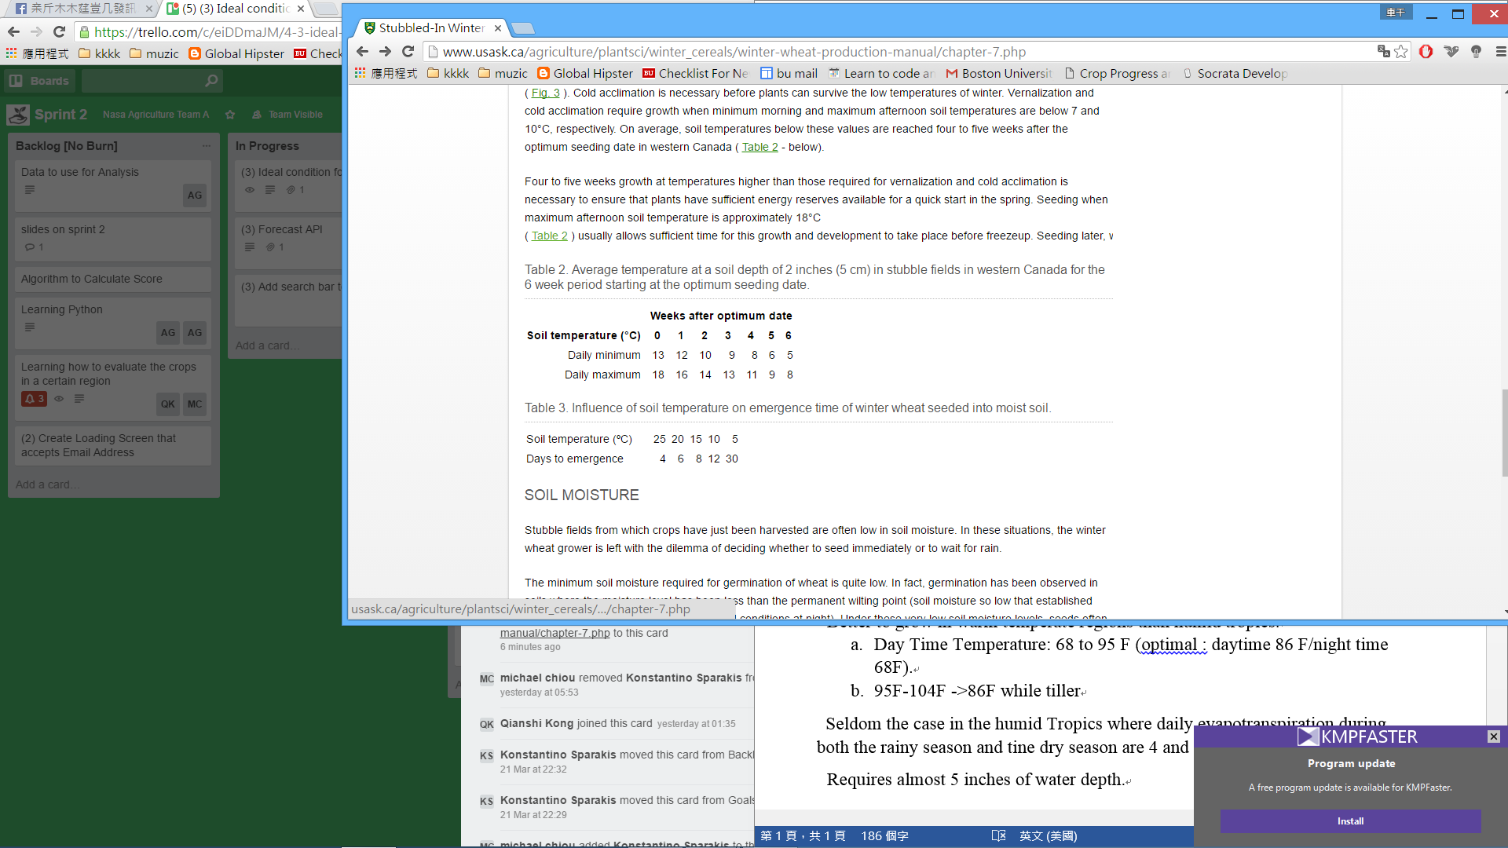

It’s a cool season crop. Heat tolerance is much lower than soybean.

Growth resume in spring.

Spring

Spring wheat does not require chilling for heading and it is day-neutral. However, it is also sensitive to frost.

1. RICE

Need constant supply of water. Can grow where mean temperature is 70 F. Better to grow in warm temperate regions than humid tropics.

* 1. Day Time Temperature: 68 to 95 F (optimal : daytime 86 F/night time 68F).
  2. 95F-104F ->86F while tiller

Seldom the case in the humid Tropics where daily evapotranspiration during both the rainy season and tine dry season are 4 and 5.5 millimeters

Requires almost 5 inches of water depth.